CUSTOMER MASTER

Do the Login

Go to Setup and maintenance , click customer master

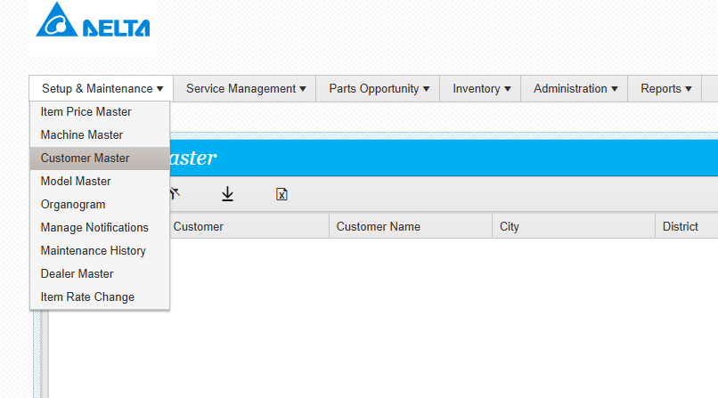

The below screen will appear

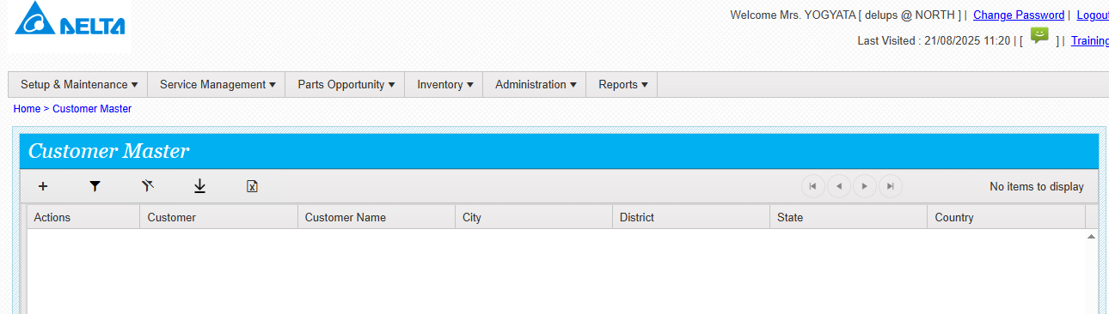

Click on plus

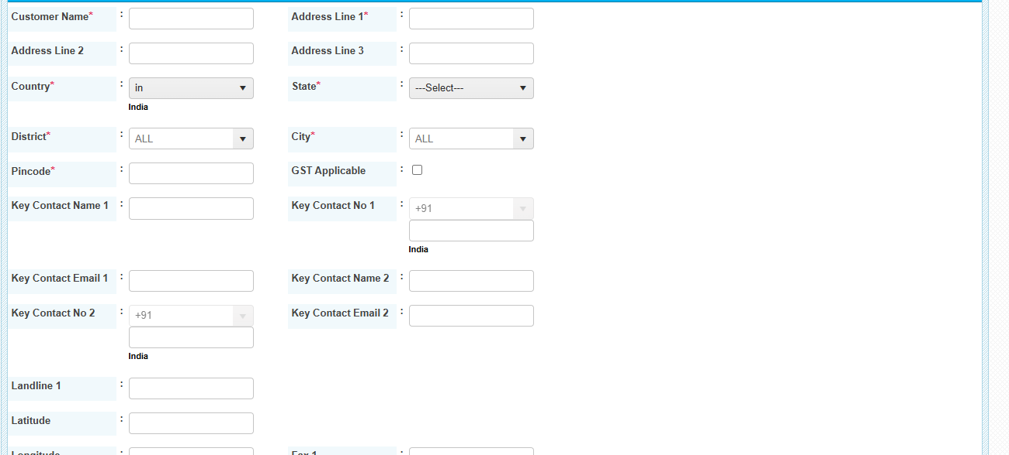

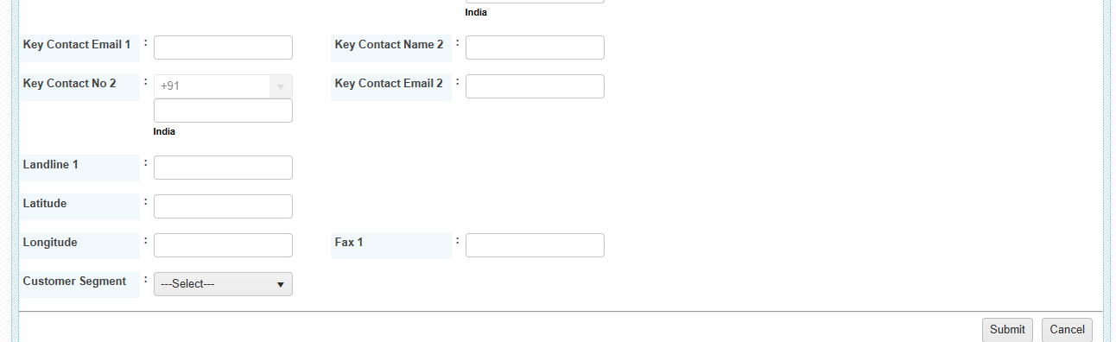

Enter all the required details and submit. Customer details saved successfully. Click on actions and click manage site

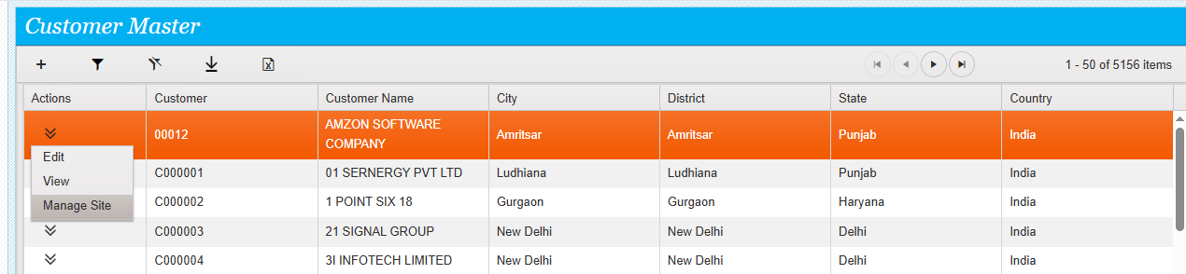

The below screen will appear

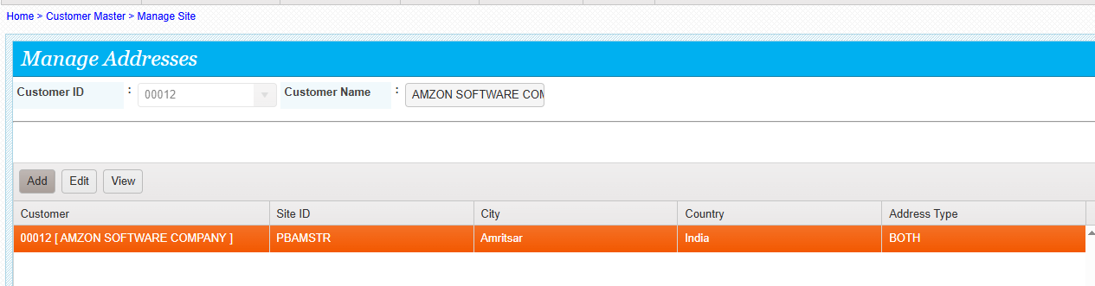

Click on add to add more site addresses

